in partnership with


ICT40515 Certificate IV in Programming
  - Adding a back-end to hold data sent by your applications
SP3/Module 5 Assessment

Assessment: 33127/01

© Open Colleges Pty Ltd, 2016

All rights reserved. No part of the material protected by this copyright may be reproduced or utilised in any form or by any means, electronic or mechanical, including photocopying, recording, or by any information storage and retrieval system, without permission in writing from the copyright owner.

All terms mentioned in this text that are known to be trademarks or service marks have been appropriately capitalised. Use of a term in this text should not be regarded as affecting the validity of any trademark or service mark.

Assessment task 33127/01

Introduction
This assessment will test your skills and knowledge gained through completing the learning and activities in Module 5: Adding a back-end to hold data sent by your applications.
This is a three-part assessment – this first assessment part (33127/01) will need to be completed and submitted to your trainer for marking and feedback before you move onto the second part (PART B: 33127/02). The third assessment is a short answer questionnaire (33127/03).
In the first two assessments (Part A and Part B), you will be presented with a case study which describes a business owner who requires your help to design and create a database to replace her Excel spreadsheet used for the recording of sales.
In Part A, you will analyse the current system and create a database design to streamline her business needs. You will present a report on your analysis and the database design.
In Part B you will create the database and tables, a database diagram, a number of SQL queries, views, stored procedures and functions for use by developers who will eventually create a front end application to the database you create.
In Part C you will provide short answers to a number of questions which will test your knowledge on databases.
Please use the checklist at the end of this document to ensure you have provided all the necessary pieces of evidence for this assessment.

Note – you must successfully complete ALL assessments (33127/01, 33127/02 and 33127/03) to achieve competency in:

ICTDBS403 Create basic databases
ICTPRG402 Apply query language
ICTSAD501 Model data objects

CASE STUDY

Carlotta’s Antique Jewellery
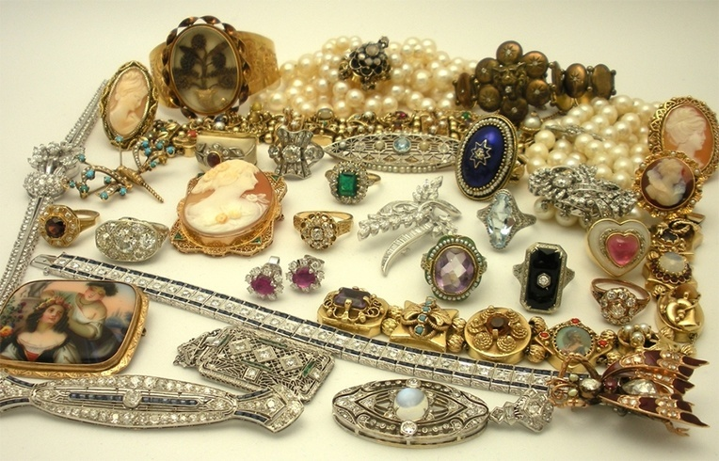
Image:bookstube

Outline

Carlotta sells antique jewellery from a shop in Sydney. She sources her jewellery from deceased estates and resellers. Carlotta is particular of the type of antique jewellery she stocks, only purchasing high end and unique jewellery. She usually prefers to purchase jewellery made before 1940, but will consider purchasing jewellery crafted between 1940 and 1960 depending on the quality of the item. Her customers all have an appreciation for rare and old jewellery.

Carlotta currently records sales on a spreadsheet. She has a separate spreadsheet for each year. You can download a sample of her spreadsheet here.

She records the customer’s name and address, the items(s) they have purchased, the type of jewellery and year it was made, the date of sale and the sale amount of the item in addition to the total sale amount. Each piece of jewellery sold is unique, that is no pieces of jewellery are the same. She also records the age group that her customers belong to so that she can do some marketing analysis. She caters for up to three sale items. If a customer purchases more than three items, she creates another line. Finally, she also records if they want to receive her newsletter.

After a few years, her system of recording sales has become unmanageable. Sales analysis has become extremely difficult as information is dispersed across multiple spreadsheets. She has heard that a database will solve her problems and make sales recording much easier. She requires the following information from the database: a mailing list for customers who want to receive her newsletter, a list of sales by item type, a list of sales by customer category and sales by month.
She has come to you to design and develop a database for her. Your findings and analysis will be compiled into a report.

PART A: Tasks 1–4
DESIGN THE DATABASE

Read the case study above thoroughly and highlight, make notes, or extract the important information about Carlotta’s Antique Jewellery. In the following tasks you will need to use this information to investigate the project further.

Task 1: Gather and evaluate information
You must analyse Carlotta’s requirements and the issues she faces, documenting your analysis in a Database Design Document. (Normally, you would document your analysis in a Software Requirements Document, which you will learn about in the next module).
Download the Database Design Document template here.
Rename the file to: <student Number>_Database Design Requirements.docx, for example, 665437_Database Design Requirements.docx
Write a requirements brief stating what is required and the challenges faced. Describe the current business process, business rules and system.
List the database system that you will use and the database security you will incorporate.
Write no more than two paragraphs.
Submit:
- Completed Requirements Brief in the Database Design Document.

Task 2: Entity Relationship Diagram (ERD)
Based on Carlotta’s sales spreadsheet, create an ERD which represents:
- the entities
- the relationship between the entities and a description of the relationship
- the cardinality between the entities.
Place your ERD in the Entity Relationship Diagram section in the Database Design Document

Submit:
- An ERD in the Database Design Document.

Task 3: Normalise the database
Task 3.1
From your analysis of Carlotta’s spreadsheet, create a list of data integrity problems with the spreadsheet that need to be addressed to create a normalised database design. List these integrity problems in the ‘Normalisation Issues’ section of the Database Design Document.
Task 3.2
Draw a rough database schema that reflects the entities in your ERD that meet the first, second and third form normalisation rules – including any required joining tables. Compare the final database schema to your ERD and address any discrepancies. You will create your tables from this database schema and create a formal database schema in Part B of the assessment.
Submit:
- A list of data integrity problems in the Database Design Document.
- A copy of your rough database schema in the Database Design Document.

Task 4: Submit report for approval.
Your assessor will act as the client for Carlotta. The Database Design Document is to be submitted to the client. You are to validate the data model with the client and resolve any issues. Finally, submit the Database Design Document for approval.

Next steps for you:
You have now reached the end of this assessment.
Ensure that you have completed all of the above tasks. Use the checklist on the next page to double check that you have provided everything required for this assessment submission.
Ensure you have renamed your Database Design Document to include your student number as specified in task one and upload to OpenSpace.
Your trainer will provide you with feedback for this PART A assessment – ensure that you read this feedback carefully as the trainer will be acting as ‘the client’.
Important: You need to wait until you receive feedback from your trainer before completing the PART B assessment.
In the next assessment (33127/02 – PART B) you will demonstrate your knowledge of SQL.
Checklist of items to submit as evidence for this assessment:

PART A
TASK 1 | Completed Requirements Brief: Database Design Document
TASK 2 | Entity Relationship Diagram (ERD): Database Design Document
TASK 3 | List of data integrity problems: Database Design Document
TASK 3 | Rough database schema: Database Design Document
Name each assessment file appropriately and submit for marking.

